

SOFTWARE MANUAL
Selected Header name

Table of Contents
Table of Figures 3
Revision records 4
1. Introduction 5
2. Select Header for Convert Excel to Access 6
Table of Figures
Figures 1: UI for select header 6
Figures 2: Default after import excel file 8
Figures 3: Total sheet in Excel 8
Figures 4: Header names are derived from the excel file 9
Figures 5: Show results before conversion 10
Figures 6: Convert AccessDB Completed 11

Revision records
Date | Version | In-charge person | Revision records
2025-Jul-25

Introduction
Selected Header Name Software is created for users to select mapping header names from the original Excel file to convert it to Access DB. The main purpose is to make the table formats consistent for ease of use and data querying for display purposes, since some datasets may have names that don't match the query requirements.
The software essentially helps standardize column headers when converting Excel files to Access databases, ensuring data consistency and making it easier to work with and query the converted data.

Select Header for Convert Excel to Access


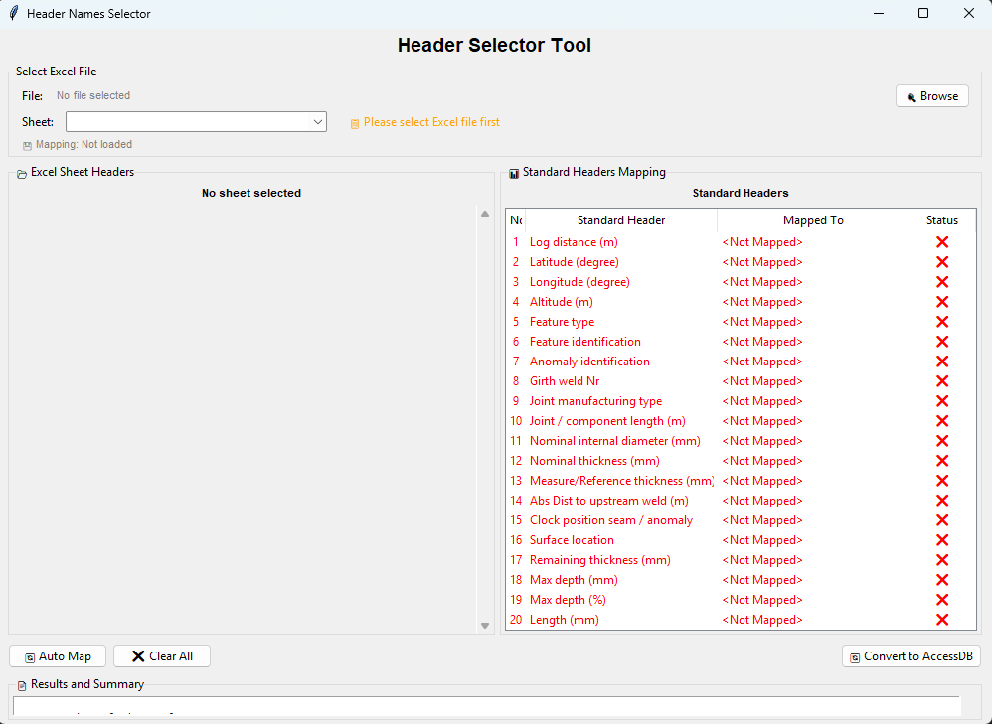
Figures 1: UI for select header

Steps to🔧 Header Selector
- Open Software => Reporting => Convert Excel to DB
- 🔍 Browse => to select Excel file
- Sheet => Select Sheet from dropdown (sheets are ordered as in Excel file)
- Excel Sheet Haeder => Headers from the Excel file of that specific sheet (If any columns have duplicate names, they will be as a dropdown.)
- Standard Header Mapping => View mapping with standard headers These are the standard headers that are predefined for use in Access DB to maintain a standard format
The standard header has 24 columns. Any columns that don't match the standard will be added as TempData after the Comments column.
- 🔄 Auto Map Button => Button for automatically mapping headers from Excel to standard headers (In case of duplicate column names, the dropdown will select the first column in order)
- Clear all Button => For clearing the mapped data
- Convert to AccessDB => For converting the selected data to AccessDB

Note!!💡 Features:
- Mappings are saved per sheet automatically
- First occurrence of duplicate columns selected by default
- In case there are columns with duplicate names, all sheets need to be mapped
- Unmapped Excel columns become TempData1, TempData2, etc.
- All sheets converted
- together with individual mappings
Default after import excel file: Display records showing the number of sheets in the excel file, with the default display starting from the first sheet in the excel file. If the imported excel file has previously selected headers, they will be stored in the config file and automatically loaded immediately upon importing the excel file.

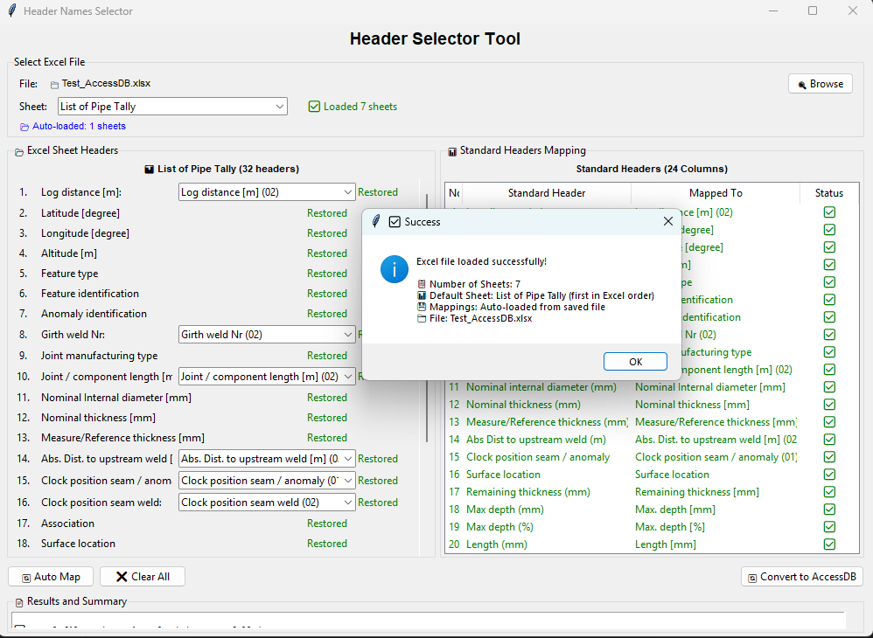
Figures 2: Default after import excel file

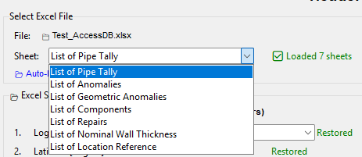
Figures 3: Total sheet in Excel

Header names: are initialized from the original excel file before any header mapping. Header names are stored in the Config file.
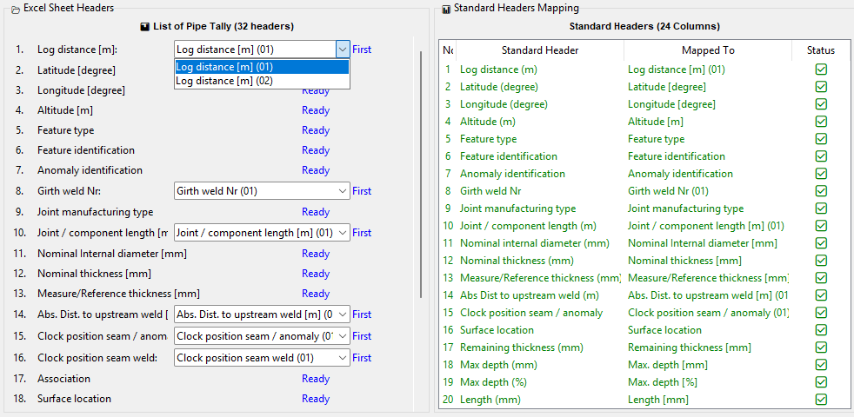
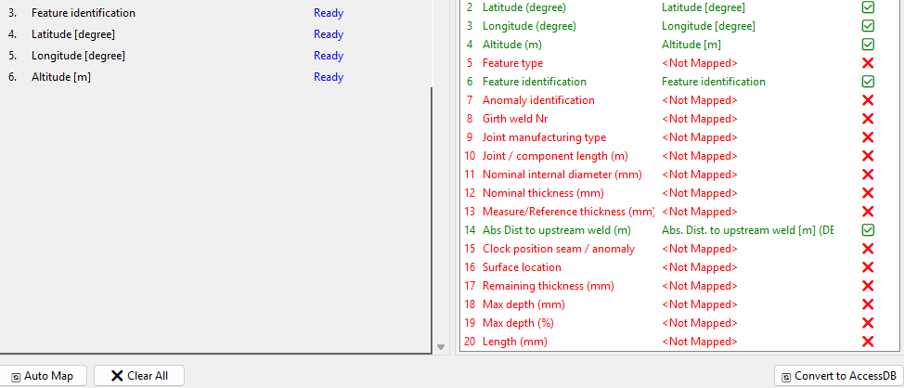
Figures 4: Header names are derived from the excel file

Dialog shows the results of header name selection prior to AccessDB conversion
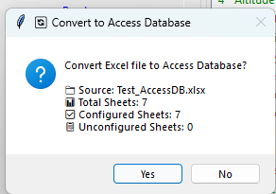
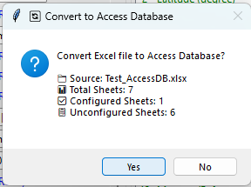
Figures 5: Show results before conversion

Steps for converting Excel to Access DB: Once you have selected the required headers, press the "Convert to Access DB" button. A progress bar will appear during conversion showing the conversion progress. Upon completion, a results dialog will be displayed showing the database location.
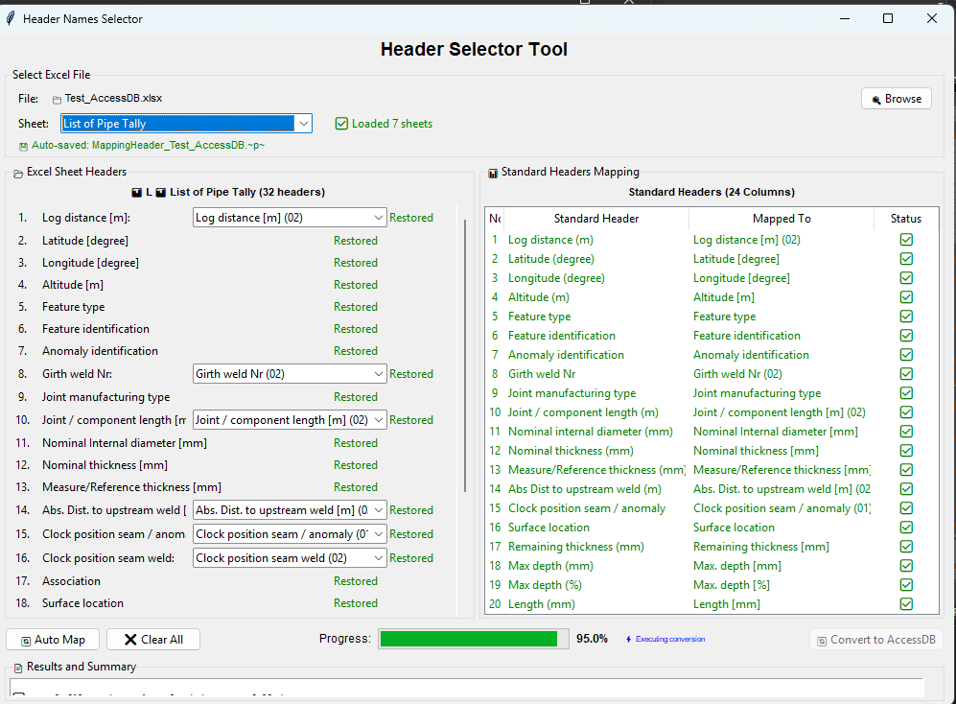
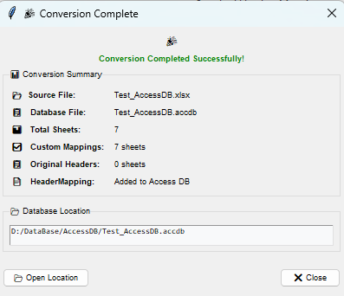
Figures 6: Convert AccessDB Completed

